Reasons for Laws:
Which are laws and rules?

Scenario | Law or Rule? Why?
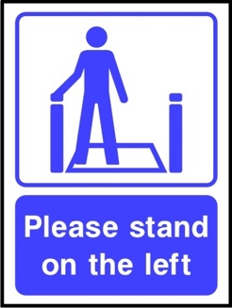
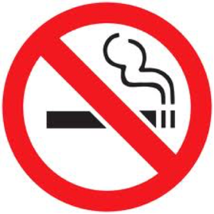
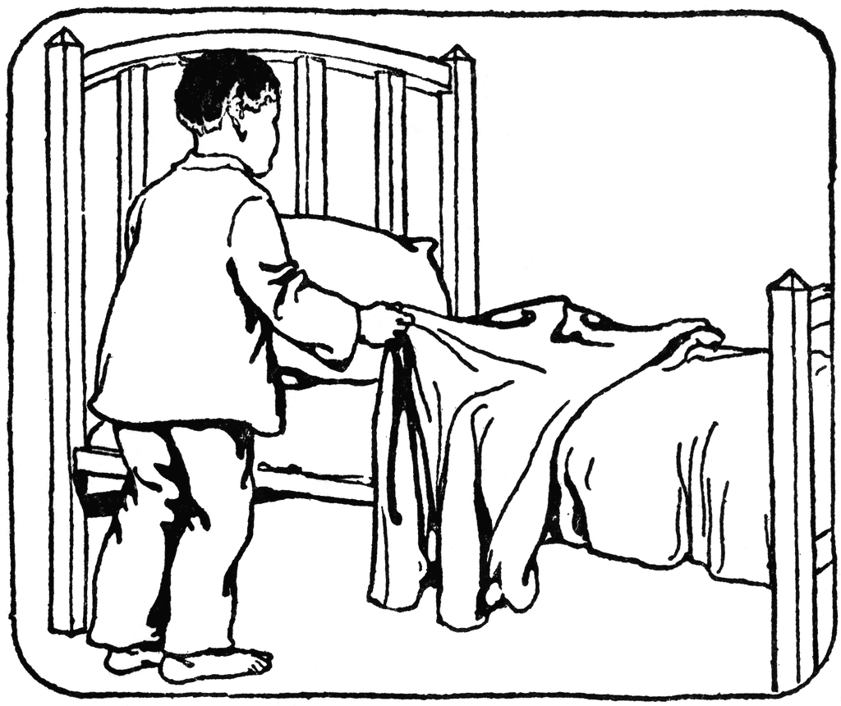
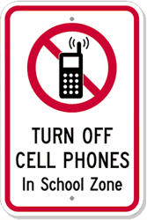
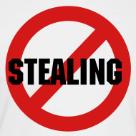
There are many laws that decide what we do and when we do it. Simple things like putting on clothes are required by law. Going to school, road rules, laws about marriages and juvenile laws are all examples of laws.

Laws have been around for over 4000 years. Laws in ancient civilizations were strict, usually resulting in physical punishments or even death.

Without laws, there would be chaos. In the table below, decide whether they would describe the following situations as legally wrong, morally wrong or both.

Crime | Legally wrong | Morally wrong
Shoplifting
Dealing drugs to young children
Killing someone
Killing someone in self-defence
Killing someone while fighting at war
Stealing prescription drugs for a dying patient
Stealing a loaf of bread for someone who is starving

