Techniques behind the ‘Coke’ ads
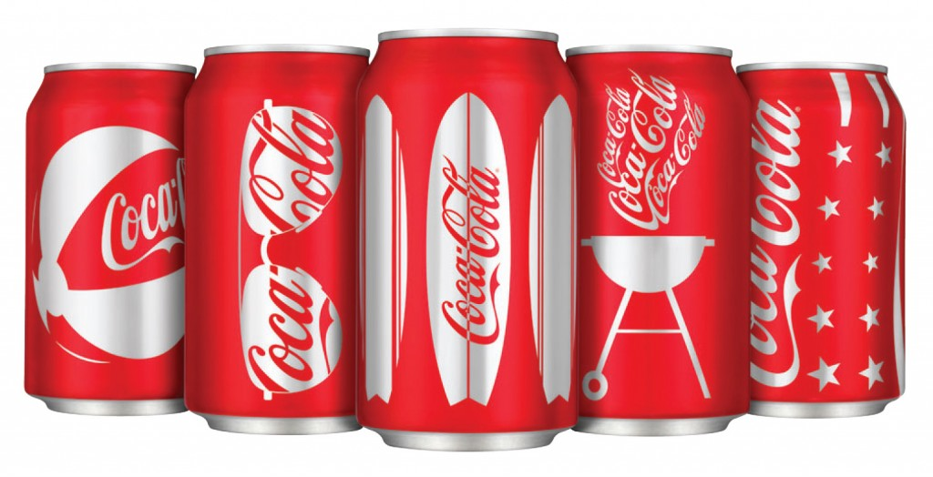

ANNOTATIONS

- Choose at least 6 of the advertisements located on the website (at least ONE video)

- Annotate and explain how you think coca cola have used the following features in their design to reflect or attract the target market:
- Layout/layering- What is in the forefront and behind the image which stand out the most
- Character/Person
- Colours used and why
- Themes
- Icons- Significant objects
- Unique selling point (USP)

Advertisement | Characters | Colours | Themes | Icons | USP
1 – (Include Description)

- In a paragraph evaluate why you think Coca Cola has been such a successful company in promoting its products.

